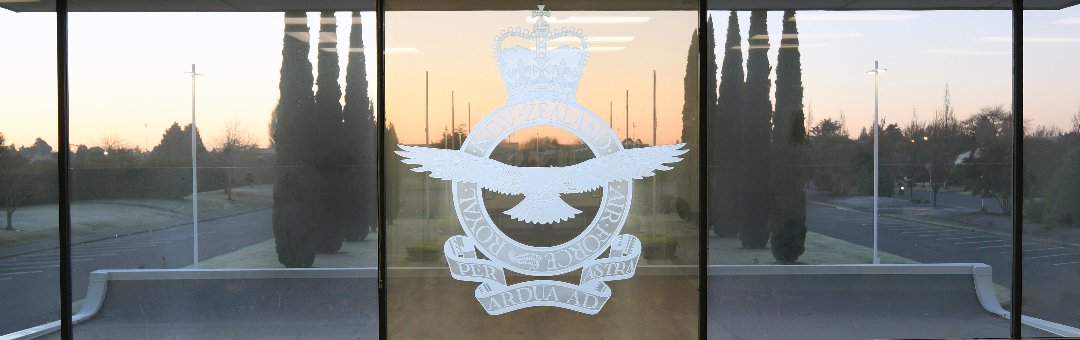

**THE BREVET CLUB (CANTERBURY) Inc**

**CANTERBURY’S CLUB FOR AIRCREW**

**C/- AIRFORCE MUSEUM OF NEW ZEALAND, PRIVATE BAG 4739, CHRISTCHURCH 8042**

**August 2023 NEWSLETTER**

**COMMITTEE**

President: Graeme Thomson 021 633 181

Vice President: Keith Jolly 351 3399

Secretary: Mark Wilson 3650277

Treasurer: Peter Foster 0275566893 & Kenn Cox 021543459

Graham Bethell (03) 318 1929 John Lay 3410418 Kevin Jones 0274 717565

Ross Cammell 027 274 9813

Honorary Padre: The Very Reverend Michael H Brown 377 7275

**PRESIDENTS REPORT AUGUST 2023**

**From the Flight Deck**

This is my first message as the new President, and it will be relatively brief and to the point and I can then stop the Vice-President “nagging” me. Essentially this will be a run down of our last committee meeting and what we discussed.

Firstly, we must all congratulate Kevin and Diann on their sterling efforts over two terms when Kevin was President of the Club, the first being an extended term of three years, and the second the standard two-year term and as a Club we owe both a debt of gratitude. As I mentioned at the AGM, I intend to carry out a standard two-year term.

My concern is very much on a par with Kevin’s as to the future of the club and its ongoing feasibility. It is gratifying to see that in recent times there has been an increase in the numbers applying for membership and ultimately it will be in the hands of this generation, following the current ageing generation to continue the Brevet Club into the future. To this end we welcomed Ross Cammell onto the Committee at our last meeting as well as Mark (Spot) Wilson accepting the position of Secretary. Kenn Cox has also re-joined the Committee and is understudying Peter Foster in his Treasurer’s role

At the meeting I shared a few of my ideas which we could look at going forward. I am hopeful that I can coerce a Club member to construct a survey soon. I do believe that a social afternoon every two weeks Is a becoming a little problematic with our current numbers. I would like to survey the feeling of the members to perhaps having the one social afternoon a month, maybe the first Tuesday of each month, but retaining at least six lunches a year with the possibility of an extra couple to be held at the Brevet Lounge. This will allow Pulp Kitchen to prove to us that “hick-ups” last year are a thing of the past. The possibility of a bus trip will also be investigated.

The social programme for the balance of this year is:

15 Aug 23 - Social afternoon, Brevet Lounge (1330)

29 Aug 23 - Luncheon, Chateau on the Park (No social afternoon in Brevet Lounge 29 Aug)

12 Sep 23 - Social afternoon, Brevet Lounge (1330)

17 Sep 23 – Battle of Britain service (1030).refreshments after in the Brevet Lounge.

26 Sep 23 - Social afternoon, Brevet Lounge (1330)

10 Oct 23 - Committee Meeting, Donaldson Room (1230)

10 Oct 23 - Social afternoon, Brevet Lounge (1330)

24 Oct 23 - Social afternoon cancelled

25 Oct 23 - Luncheon, Chateau on the Park (No social afternoon in Brevet Lounge 24 Oct)

07 Nov 23 - Social afternoon, Brevet Lounge (1330)

21 Nov 23 - Committee Meeting, Donaldson Room (1230)

21 Nov 23 - Social afternoon, Brevet Lounge (1330)

05 Dec 23 - Social afternoon cancelled

06 Dec 23 – Luncheon, Brevet Lounge (No social afternoon in Brevet Lounge 05 Nov)

19 Dec 23 - Social afternoon, Brevet Lounge (1330) - Final social afternoon for 2023

The first social afternoon for 2024 will be 16 Jan 24.

first social afternoon for 2024 will be 16 Jan 2

Our oldest member Jack Marshall turned 103 last week and is currently in respite care. Our Honorary Chaplain, Michael Brown is currently in Burwood Hospital and his family are hoping to be able to move him closer to family in the North Island soon.

I had a meeting with NZTA/Waka Kotahi recently in relation to the Sir Keith Park Flyover proposal and it will be a drawn-out process while they go through various consultations, but I guess we have been at it long enough now another few months becomes irrelevant.

Well, that is all for now, stay safe, stay warm and spring is just around the corner.

Cheers

Graeme

**SOME FUN IN THE MOUNTAINS**

**STRANDED**

The C-130 was ready to return to McMurdo from the newly established Siple Station but for reasons unknown it had used it’s last JATO bottles and was basically stranded on the plateau at 10,000 feet. The skipper was an enterprising type and had observed topdressing in New Zealand and Mt Cook ski planes.

He had an idea:

“Nav”

“Yes skipper”

“Where’s the nearest decent hill?”

Much rustling of topo charts followed

“Erm 48 miles due ……. that way”

“Perhaps we’ll go there then, maybe have some lunch along the way?”

Some time later they reached the bottom of the hill which they climbed and turned 180 when they could go no higher. Full power, crossed fingers, and they were off. Problem solved.

Footnote: The following morning I met the skipper on “Main Street” McMurdo in (civilian) golfing gear chipping a golf ball to and fro. He explained the computer had just advised him he had completed his time in the Navy and he was now retired! The mind boggles, at the need to replace him all the way down south with only a few weeks left in the season.

**HOWEVER AT ABOUT THE SAME TIME**

Two twin Hueys landed on the crater rim of Mt Erebus and the crews were strolling around admiring the view and they heard a turbine winding up. Hueys have an excellent rate of climb, and sea level to 13,000 feet takes no time at all, often times with all manner of weird effects to the human mind. Steve D was cranking a Huey, door open, no belt on, Super Eight (remember them) on his lap, and it was clear he wanted some special footage. Steve was known for dare devil photography having been unsuccessfully chased away from a spot on the sea ice directly in front of an icebreaker cutting a channel to Winter Quarters Bay. The rest of the crews moved like a scrum and yanked Steve out of his seat and with much squealing and giggling managed to strap him down on the 5 cross seats which immobilised him like a straightjacket. He stayed that way until the volcanologists had finished their work, and all flew back to McMurdo. Steve was most displeased.

**NEW ROPE NEEDED**

The ski field tow rope at Scott Base was on it’s last legs, almost more splice than rope. Steve D of the story above had made quite an impressive hanging chair in our lounge using rope amongst other stuff. He advised that one of the depots had a large pallet of suitable rope for us. A plan was hatched. I was loaned a large ute and wearing my SD cap I backed up to the depot. The young sailor in charge snapped to attention, smartly saluted. I said I am the man to collect the rope and he said to follow him. We went upstairs to the loft and sure enough there was a pallet with enough rope to do the job and more. I was guided into the depot with the ute and parked below the freight hole. The pallet was lowered to the ute deck and I was off. Later that evening, after much splicing the ski tow was back in business. It is amazing, if you look and sound as if you know what you are doing, people assume that you are kosher.

**REMINDER**

It’s that time of year again. You can make your $25 payment on line to 03-0802-0585688-00 Peter or Kenn will be most pleased to receive your sub renewal.

**A TOUCH OF HISTORY**

At a recent social afternoon we listened to a delightful anecdote from Denis Hampton about his experience in the Pacific and having his “Crossing the Line” in a Sunderland witnessed by “Neptune R”. Thanks Denis, most enjoyable.

I am sure other members have stories to tell as well. All volunteers will be happily accepted.



**REMINDER**

Next luncheon 29th August, Double Tree, Chateau on the Park 1200 for 1230. Please advise and pay Kevin or Diann $20 pp by Friday 25th August.

Keith Jolly, Editor

The Price of Freedom is Eternal Vigilance